**How to Handle Dropdown in Selenium webdriver**

January 8, 2019 by [Mukesh Otwani](http://learn-automation.com/author/mukesh50/) [56 Comments](http://learn-automation.com/handle-dropdown-in-selenium-webdriver/#comments)

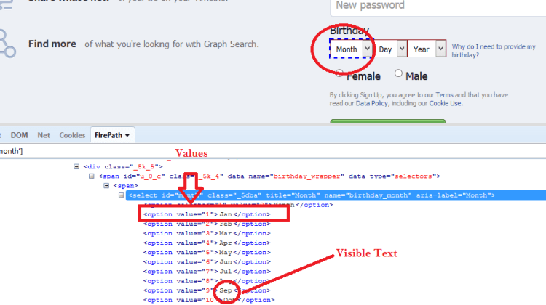

Hello, Guys, Welcome to Selenium tutorial, today in this post we will see how to handle Dropdown in Selenium webdriver.

Generally, while working with the script we have to select some values from the dropdown and do other activity and validate. The dropdown is just like simple WebElement like [**Checkbox**](http://learn-automation.com/handle-radio-button-and-checkbox-in-selenium-webdriver/), textbox etc.

Before moving to Dropdown in Selenium webdriver check out few useful posts that will help you while writing scripts.

[**Dynamic XPath in Selenium**](http://learn-automation.com/selenium-xpath-plugin-for-firefox-browser/)

[**Xpath Plugin for Chrome**](http://learn-automation.com/xpath-checker-for-chrome-browser/)**and** [**ChroPath for Chrome for XPath**](https://www.youtube.com/watch?v=kjTsGnkPQEc)

**Please refer the video for the same.**

[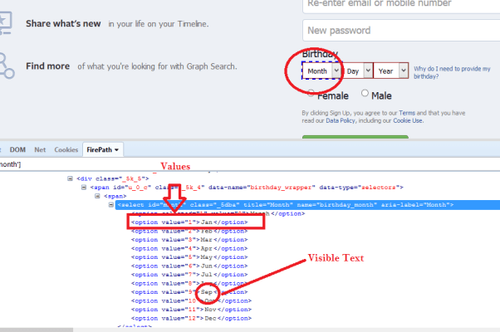](https://i1.wp.com/learn-automation.com/wp-content/uploads/2015/04/Dropdown-in-Selenium-webdriver.png)

**Select values from Dropdown in Selenium webdriver**

For handling dropdowns, Selenium already provides [Select class](https://seleniumhq.github.io/selenium/docs/api/java/org/openqa/selenium/support/ui/Select.html) that has some predefined method which help is a lot while working with Dropdown.

Select class can be find in below package.



|  |  |
| --- | --- |
| 1 | org.openqa.selenium.support.ui.Select |

**Select values Dropdown in Selenium webdriver**

Let’s Discuss some of the methods and will see the detailed program as well.

* **Select value using Index.**

WebElement month_dropdown=driver.findElement(By.id(“month”));



|  |  |
| --- | --- |
| 1  2  3 | Select month=new Select(month_dropdown);     month.selectByIndex(4); |

Explanation- Here selectbyIndex(int) is method which accept integer as argument so depends on index it will select values. If you give index as 4, it will select 5th value.

Note- Index will start from 0.

* **Select value using value attribute.**



|  |  |
| --- | --- |
| 1  2  3  4  5 | WebElement month_dropdown=driver.findElement(By.id("month"));     Select month=new Select(month_dropdown);     month.selectByValue(“5”); |

Explanation- Here selectByValue(String) is a method which accepts values it means whatever value you have in your dropdown. Please refer below screenshot to see how to get values from the dropdown.

In our example we have taken value as 5 it means it will select May from dropdown.

* **Select value from Visible text**



|  |  |
| --- | --- |
| 1  2  3  4  5 | WebElement month_dropdown=driver.findElement(By.id("month"));     Select month=new Select(month_dropdown);     month.selectByVisibleText("Aug"); |

Explanation- We can also select the value from the text as well. This is very straight forward that whatever text we are passing it simply select that value.

Note- This is case sensitive it means if I pass Aug and dropdown has aug then Selenium will not be able to select value and it will fail your program so make sure Text which you are passing is correct.

In the above example, I am passing Aug in the argument so it will select aug from the dropdown.

* **Get Selected option from Dropdown.**



|  |  |
| --- | --- |
| 1  2  3  4  5  6  7 | WebElement month_dropdown=driver.findElement(By.id("month"));     Select month=new Select(month_dropdown);     WebElement first_value=month.getFirstSelectedOption();     String value=first_value.getText(); |

Explanation- Here getFirstSelectedOption() will return the first selected option and will return you the WebElement then you can use getText() method to extract text and validate the same based on your requirement

* **Get All option from dropdown**



|  |  |
| --- | --- |
| 1  2  3  4  5  6  7  8  9  10  11  12  13 | WebElement month_dropdown=driver.findElement(By.id("month"));    Select month=new Select(month_dropdown);    List<WebElement> dropdown=month.getOptions();     for(int i=0;i<dropdown.size();i++){     String drop_down_values=dropdown.get(i).getText();     System.out.println("dropdown values are "+drop_down_values);     } |

Explanation- getOptions() is a method of Select class which will return [List of WebElement](https://www.youtube.com/watch?v=OFjYA0apYGY) then we can iterate using for loop or iterator and using getText() method we can extract values.